LAPORAN TUGAS

PEMROGRAMAN BERORIENTASI OBJEK

KELAS C

”Tugas 3”



ADRIANUS BAGAS TANTYO DANANJAYA

06111840000102

DEPARTEMEN MATEMATIKA

FAKULTAS MATEMATIKA KOMPUTASI DAN SAINS DATA

INSTITUT TEKNOLOGI SEPULUH NOPEMBER

SURABAYA

2019

1. SOAL

Pada tugas ini akan ditampilkan soal dan cara yang digunakan untuk mengerjakan soal-soal yang ada.

1. 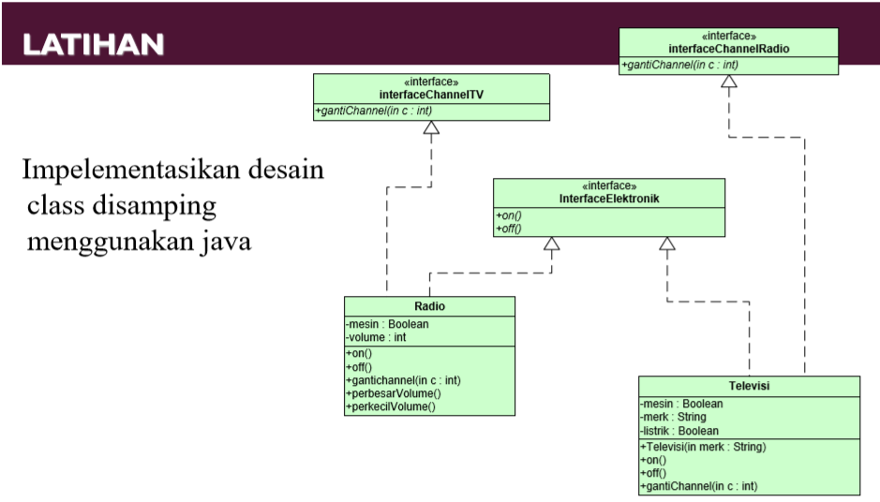Penjelasan Soal

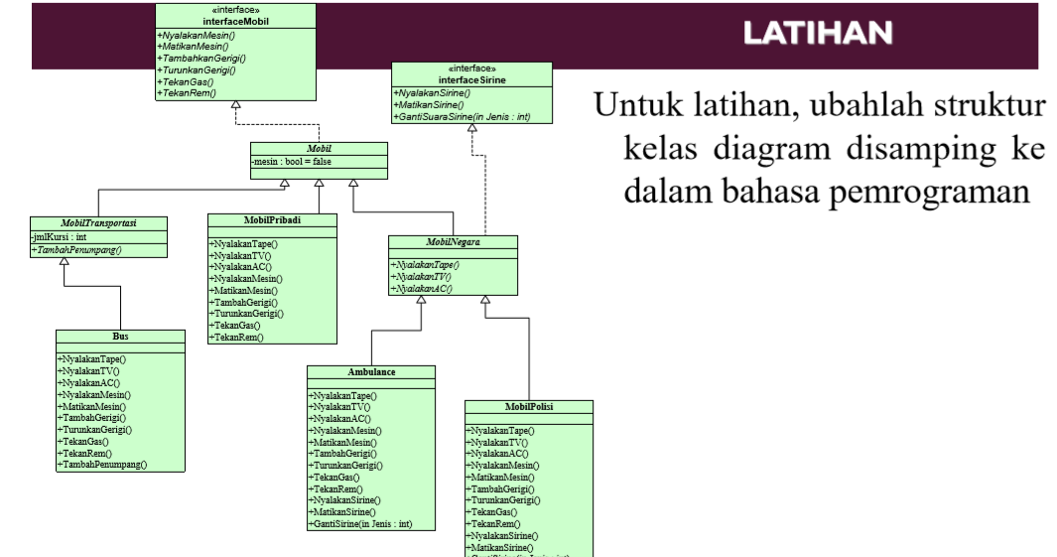

1. Metode penyelesaian

Untuk menyelesaikannya, digunakan konsep abstract dan interface. Pada UML yang pertama, class interface ada InterfaceChannelTV, InterfaceElektronik, dan InterfaceChannelRadio. Java Class ada Radio dan Televisi. Pada UML yang kedua, class interface ada InterfaceMobil dan InterfaceSirine. Class abstract ada MobilNegara dan MobilTransportasi. Java Class biasa ada MobilPribadi, MobilPolisi, Mobil, Bus, dan Ambulance.

1. SOURCE CODE

Program penyelesaian masalah tersebut yaitu:

A. UML pertama

1.Class Interface InterfaceElektronik

|  |  |
| --- | --- |
| 1  2  3  4 | public interface InterfaceElektronik {  public abstract boolean on();  public abstract boolean off();  } |

2.Class Interface InterfaceChannelTV

|  |  |
| --- | --- |
| 1  2  3 | public interface InterfaceChannelTV {  public abstract int gantichannel(int c);  } |

3.Class Interface InterfaceChannelRadio

|  |  |
| --- | --- |
| 1  2  3 | public interface InterfaceChannelRadio {  public abstract int gantichannel(int c);  } |

4.Class Radio

|  |  |
| --- | --- |
| 1  2  3  4  5  6  7  8  9  10  11  12  13  14  15  16  17  18  19  20  21  22  23  24 | public class Radio implements InterfaceElektronik, InterfaceChannelTV{  private boolean mesin;  private int volume;  public boolean on(){  mesin=true;  return mesin;  }  public boolean off(){  mesin=false;  return mesin;  }  public int gantichannel(int c){  return c;  }  public int perbesarvolume(int tambah){  volume+=tambah;  return volume;  }  public int perkecilvolume(int kurang){  volume-=kurang;  return volume;  }  } |

5.Class Televisi

|  |  |
| --- | --- |
| 1  2  3  4  5  6  7  8  9  10  11  12  13  14  15  16  17  18  19  20  21  22  23  24  25  26 | public class Televisi implements InterfaceElektronik,InterfaceChannelRadio{  private boolean mesin;  private String merk;  private boolean listrik;  public Televisi(String merk){  this.merk=merk;  }  public void setMerk(String merk){  this.merk=merk;  }  public String getMerk(){  return merk;  }  public boolean on(){  listrik=true; mesin=true;  return listrik;  }  public boolean off(){  listrik=false; mesin=false;  return listrik;  }  public int gantichannel(int c){  return c;  }  } |

6.Class MainRadio

|  |  |
| --- | --- |
| 1  2  3  4  5  6  7  8  9  10  11  12  13  14  15  16  17  18  19  20  21  22  23  24  25  26  27  28  29  30  31  32  33  34  35  36  37  38  39  40  41  42  43  44  45  46  47  48  49  50  51  52  53 | import java.util.Scanner;  public class MainRadio{  public static void main(String[] args) {  Scanner input=new Scanner(System.in);  Radio r=new Radio();  Televisi t=new Televisi("SHARP");  System.out.print("Apakah anda ingin menyalakan Radio : ");  String a=input.next();  if(a.equalsIgnoreCase("ya")){  r.on();  if(r.on()==true){  System.out.println("Radio sudah nyala");  } else {  System.out.println("Radio sudah mati");  }  System.out.print("Mau masuk channel nomor berapa : ");  int b=input.nextInt();  System.out.println("Masuk ke channel "+r.gantichannel(b));  System.out.print("Volume 0, ingin dinaikkan menjadi berapa : ");  int c=input.nextInt();  System.out.println("Volume menjadi "+r.perbesarvolume(c));  System.out.print("Ingin dikecilkan : ");  String d=input.next();  if(d.equalsIgnoreCase("ya")){  System.out.print("Ingin dikecilkan berapa : ");  int e=input.nextInt();  System.out.println("Volume menjadi "+r.perkecilvolume(e));  System.out.println("Selamat menikmati radio");  } else {  System.out.println("Selamat menikmati radio");  }  }else if(a.equalsIgnoreCase("tidak")){  r.off();  if(r.off()==true){  System.out.println("Radio sudah nyala");  } else {  System.out.println("Radio sudah mati");  }  } else {  System.out.println("Pilihannya ya atau tidak");  }  }  } |

7. Class MainTV

|  |  |
| --- | --- |
| 1  2  3  4  5  6  7  8  9  10  11  12  13  14  15  16  17  18  19  20  21  22  23  24  25  26  27  28  29  30  31  32  33  34  35 | import java.util.Scanner;  public class MainTV {  public static void main(String[] args) {  Scanner input=new Scanner(System.in);  Televisi t=new Televisi("SHARP");  System.out.println("---Selamat Datang di TV "+t.getMerk()+"---");  System.out.print("Apakah anda ingin menyalakan TV : ");  String a=input.next();  if(a.equalsIgnoreCase("ya")){  t.on();  if(t.on()==true){  System.out.println("TV sudah nyala");  } else {  System.out.println("TV sudah mati");  }  System.out.print("Mau masuk channel berapa : ");  int b=input.nextInt();  System.out.println("Masuk ke channel "+t.gantichannel(b));  System.out.println("Selamat menonton");  } else if(a.equalsIgnoreCase("tidak")){  t.off();  if(t.off()==true){  System.out.println("TV sudah nyala");  } else{  System.out.println("TV sudah mati");  }  } else {  System.out.println("Pilihannya ya atau tidak");  }  }  } |

B. UML kedua

1. Class Interface InterfaceMobil

|  |  |
| --- | --- |
| 1  2  3  4  5  6  7  8 | public interface InterfaceMobil {  public abstract void nyalakanmesin();  public abstract void matikanmesin();  public abstract void tambahkangerigi();  public abstract void turunkangerigi();  public abstract void tekangas();  public abstract void tekanrem();  } |

2.Class Interface InterfaceSirine

|  |  |
| --- | --- |
| 1  2  3  4  5 | public interface InterfaceSirine {  public abstract void nyalakansirine();  public abstract void matikansirine();  public abstract void gantisuarasirine(int jenis);  } |

3.Class Abstract MobilNegara

|  |  |
| --- | --- |
| 1  2  3  4  5  6 | public abstract class MobilNegara extends Mobil implements InterfaceSirine {  public abstract void nyalakantape();  public abstract void nyalakantv();  public abstract void nyalakanac();  } |

4.Class Abstract MobilTransportasi

|  |  |
| --- | --- |
| 1  2  3  4 | public abstract class MobilTransportasi extends Mobil{  protected int jmlkursi;  public abstract void tambahpenumpang();  } |

5.Class Mobil

|  |  |
| --- | --- |
| 1  2  3  4  5  6  7  8  9  10  11  12  13  14  15  16  17  18  19  20  21  22  23  24  25  26  27  28  29  30  31  32  33  34 | public class Mobil implements InterfaceMobil {  private int gerigi = 0;  private boolean mesin = false;  private int kecepatan=0;  public void nyalakanmesin(){  mesin = true;  System.out.println("Mesin menyala");  }  public void matikanmesin(){  mesin = false;  System.out.println("Mesin mati");  }  public void tambahkangerigi(){  if (mesin)  gerigi++;  if(gerigi==6)  gerigi = 1;  System.out.println("Gerigi : "+gerigi);  }  public void turunkangerigi(){  if (mesin)  gerigi--;  if(gerigi==-1)  gerigi=5;  }  public void tekangas() {  if (mesin)  kecepatan++;  }  public void tekanrem() {  if (mesin)  kecepatan--;  }  } |

6. Class MobilPribadi

|  |  |
| --- | --- |
| 1  2  3  4  5  6  7  8  9  10  11  12  13  14  15  16  17  18  19  20  21  22  23  24  25  26  27  28  29  30  31  32  33  34  35  36  37  38  39  40  41  42  43  44  45  46  47  48  49  50 | public class MobilPribadi extends Mobil{  private boolean mesin,tape,tv,ac;  private int gerigi=0;  private int kecepatan=0;  public void nyalakantape(){  if (mesin==true)  tape = true;  System.out.println("Tape Menyala");  }  public void nyalakantv(){  if (mesin==true)  tv = true;  System.out.println("TV menyala");  }  public void nyalakanac(){  if (mesin==true)  ac=true;  System.out.println("AC menyala");  }  public void nyalakanmesin() {  mesin = true;  System.out.println("Mesin menyala");  }  public void matikanmesin() {  mesin = false;  System.out.println("Mesin mati");  }  public void tambahkangerigi() {  if (mesin)  gerigi++;  }  public void turunkangerigi() {  if (mesin)  gerigi--;  }  public void tekangas() {  if (mesin)  kecepatan+=10;  }  public void tekanrem() {  if (mesin)  kecepatan-=10;  }  public int getkecepatan(){  return kecepatan;  }  public int getgerigi(){  return gerigi;  }  } |

7. Class Bus

|  |  |
| --- | --- |
| 1  2  3  4  5  6  7  8  9  10  11  12  13  14  15  16  17  18  19  20  21  22  23  24  25  26  27  28  29  30  31  32  33  34  35  36  37  38  39  40  41  42  43  44  45  46  47  48  49  50  51  52  53  54  55  56 | public class Bus extends MobilTransportasi {  private boolean mesin, tape, tv, ac;  private int gerigi = 0;  private int kecepatan = 0;  public void nyalakantape(){  if (mesin==true){  tape = true;  System.out.println("Tape menyala");  }  }  public void nyalakantv(){  if(mesin==true)  tape = true;  System.out.println("TV menyala");  }  public void nyalakanac(){  if (mesin==true){  ac = true;  System.out.println("AC menyala");  }  }  public void nyalakanmesin(){  mesin = true;  System.out.println("Mesin menyala");  }  public void matikanmesin(){  mesin = false;  System.out.println("Mesin mati");  }  public void tambahkangerigi(){  if (mesin==true)  gerigi++;  }  public void turunkangerigi(){  if(mesin==true)  gerigi--;  }  public void tekangas(){  if(mesin==true)  kecepatan+=10;  }  public void tekanrem(){  if (mesin==true)  kecepatan-=10;  }  public void tambahpenumpang() {  int penumpang = 0;  if(penumpang<jmlkursi)  penumpang--;  }  public int getkecepatan(){  return kecepatan;  }  public int getgerigi(){  return gerigi;  }} |

8. Class Ambulance

|  |  |
| --- | --- |
| 1  2  3  4  5  6  7  8  9  10  11  12  13  14  15  16  17  18  19  20  21  22  23  24  25  26  27  28  29  30  31  32  33  34  35  36  37  38  39  40  41  42  43  44  45  46  47  48  49  50  51  52  53  54  55  56  57  58  59  60  61  62  63  64  65  66  67  68  69 | public class Ambulance extends MobilNegara {  private boolean mesin, tape,tv, ac, sirine;  private int gerigi =0;  private int kecepatan = 0;  private String jenisSirine;  public void nyalakantape() {  if(mesin==true)  tape = true;  System.out.println("Tape menyala");  }  public void nyalakantv() {  if (mesin==true)  tv=true;  System.out.println("TV menyala");  }  public void nyalakanac() {  if(mesin==true)  ac=true;  System.out.println("AC menyala");  }  public void nyalakanmesin(){  mesin = true;  System.out.println("Mesin menyala");  }  public void matikanmesin(){  mesin = false;  System.out.println("Mesin mati");  }  public void tambahkangerigi(){  if (mesin==true)  gerigi++;  }  public void turunkangerigi(){  if (mesin==true)  gerigi--;  }  public void tekangas(){  if(mesin==true)  kecepatan+=10;  }  public void tekanrem(){  if(mesin==true)  kecepatan-=10;  }  public void nyalakansirine() {  if (mesin==true)  sirine=true;  System.out.println("Sirine menyala");  }  public void matikansirine() {  if (mesin== true)  sirine= false;  System.out.println("Sirine mati");  }  public void gantisuarasirine(int Jenis) {  switch(Jenis){  case 0 : System.out.println("Sirine : tetot");;break;  case 1 : System.out.println("Sirine : dindin");;break;  }  }  public int getkecepatan(){  return kecepatan;  }  public int getgerigi(){  return gerigi;  }  } |

9. Class MobilPolisi

|  |  |
| --- | --- |
| 1  2  3  4  5  6  7  8  9  10  11  12  13  14  15  16  17  18  19  20  21  22  23  24  25  26  27  28  29  30  31  32  33  34  35  36  37  38  39  40  41  42  43  44  45  46  47  48  49  50  51  52  53  54  55  56  57  58  59  60  61  62  63  64  65  66  67  68  69  70  71  72  73  74  75  76  77 | public class MobilPolisi extends MobilNegara {  private boolean mesin, tape, tv, ac, sirine, HT;  private int gerigi = 0;  private int kecepatan = 0;  private String jenisSirine;  public void nyalakantape() {  if(mesin== true)  tape = true;  System.out.println("Tape menyala");  }  public void nyalakantv() {  if(mesin== true)  tv = true;  System.out.println("TV menyala");  }  public void nyalakanac() {  if(mesin== true)  ac = true;  System.out.println("AC menyala");  }  public void nyalakanmesin(){  mesin = true;  System.out.println("Mesin menyala");  }  public void matikanmesin(){  mesin = false;  System.out.println("Mesin mati");  }  public void tambahkangerigi(){  if(mesin== true)  gerigi++;  }  public void turunkangerigi(){  if(mesin== true)  gerigi--;  }  public void tekangas(){  if(mesin== true)  kecepatan++;  }  public void tekanrem(){  if(mesin== true)  kecepatan--;  }  public void nyalakansirine() {  if(mesin== true)  sirine = true;  System.out.println("Sirine menyala");  }  public void matikansirine() {  if(mesin== true)  sirine = false;  System.out.println("Sirine mati");  }  public void gantisuarasirine(int Jenis) {  switch(Jenis){  case 0 : System.out.println("tetot");;break;  case 1 : System.out.println("dindin");;break;  }  }  public void nyalakanradioht(){  if(mesin== true)  HT= true;  System.out.println("HT menyala");  }  public void matikanRadioht(){  if(mesin== true)  HT = false;  System.out.println("HT mati");  }  public int getkecepatan(){  return kecepatan;  }  public int getgerigi(){  return gerigi;  }  } |

10. Class MainKendaraan

|  |  |
| --- | --- |
| 1  2  3  4  5  6  7  8  9  10  11  12  13  14  15  16  17  18  19  20  21  22  23  24  25  26  27  28  29  30  31  32  33  34  35  36  37  38  39  40  41  42  43  44  45  46  47  48  49  50  51  52  53  54  55  56  57  58  59  60  61  62  63  64  65  66  67  68  69  70  71  72 | public class MainKendaraan {  public static void main(String[] args) {  MobilPribadi a = new MobilPribadi();  Bus b = new Bus();  Ambulance c = new Ambulance();  MobilPolisi d = new MobilPolisi();    System.out.println("---Mobil Pribadi---");  a.nyalakanmesin();  a.nyalakanac();  a.nyalakantape();  a.nyalakantv();  a.tambahkangerigi();  a.tambahkangerigi();  a.tekangas();  System.out.println("Gerigi mobil pribadi :"+a.getgerigi());  System.out.println("kecepatan mobil pribadi :"+a.getkecepatan());    System.out.println();    System.out.println("---Bus---");  b.nyalakanmesin();  b.nyalakanac();  b.nyalakantape();  b.nyalakantv();  b.tambahkangerigi();  b.tekangas();  System.out.println("Gerigi mobil bus :"+b.getgerigi());  System.out.println("kecepatan mobil bus :"+b.getkecepatan());    System.out.println();    System.out.println("---Ambulance---");  c.nyalakanmesin();  c.nyalakanac();  c.nyalakantape();  c.nyalakantv();  c.tambahkangerigi();  c.tambahkangerigi();  c.tambahkangerigi();  c.tekangas();  c.tekangas();  c.tekangas();  c.gantisuarasirine(0);  System.out.println("Gerigi mobil ambulance :"+c.getgerigi());  System.out.println("kecepatan mobil ambulance :"+c.getkecepatan());    System.out.println();    System.out.println("---Mobil Polisi---");  d.nyalakanmesin();  d.nyalakanac();  d.nyalakantape();  d.nyalakantv();  d.tambahkangerigi();  d.tambahkangerigi();  d.tekangas();  d.tekangas();  d.gantisuarasirine(1);  d.nyalakanradioht();  System.out.println("Gerigi mobil polisi :"+d.getgerigi());  System.out.println("kecepatan mobil pribadi :"+d.getkecepatan());  }  } |

1. RUNNING PROGRAM

Hasil outputan dari beberapa input yang dimasukkan dalam program yaitu:

1. UML pertama

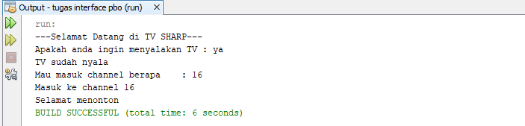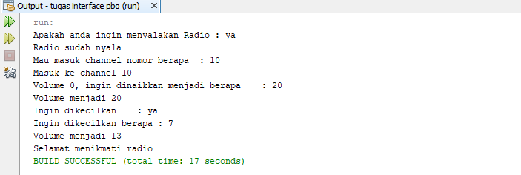

1. 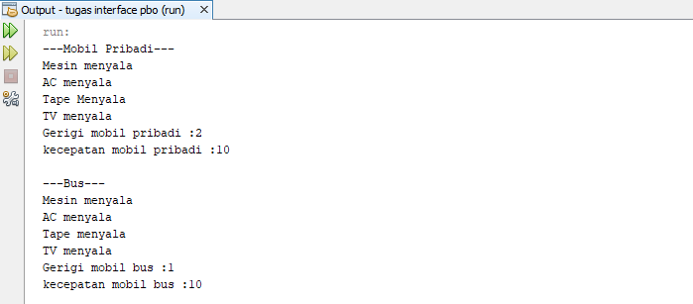UML kedua

